Name: Anand Krishnamoorthy

CSCI S-89 Introduction to Deep Learning

Assignment 2

**Problem 1 (15 points)**

Please consider the following example of a Neural Network for text classification found in

3.6-Classifying_newswires_a_multiclass_classification_example.ipynb:

model = models.Sequential()

model.add(layers.Dense(64, activation='relu', input_shape=(10000,)))

model.add(layers.Dense(64, activation='relu'))

model.add(layers.Dense(46, activation='softmax'))

model.compile(optimizer='rmsprop',

loss='categorical_crossentropy',

metrics=['accuracy'])

model.fit(partial_x_train,

partial_y_train,

epochs=20,

batch_size=512,

validation_data=(x_val, y_val))

results = model.evaluate(x_test, one_hot_test_labels)

Please use a train set of 6982 samples and validation set of 2000 samples to train the network. Identify the optimal number of epochs based on the validation accuracy. Plot the results for accuracy versus number of epochs. Report the test accuracy of the model when trained with the optimal number of epochs.

SOLUTION:

Architecture used : 3.6-Classifying_newswires_a_multiclass_classification_example.ipynb.

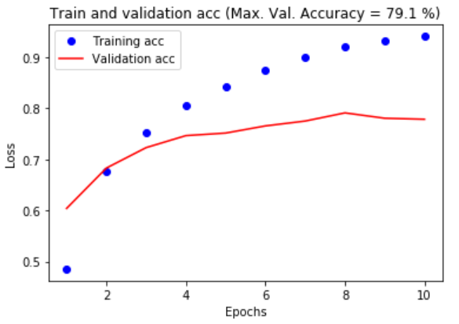

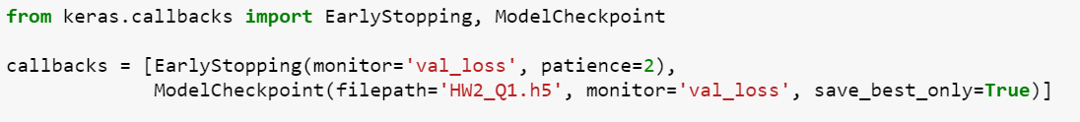Using the EarlyStopping function is Keras yielded 10 as the optimal # of epochs. 8th epoch yielded the highest accuracy of 79.1%.

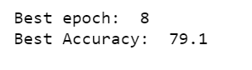

**Problem 2 (35 points)**

Consider the network from Problem 1 and examine the effect of L2 regularization on the optimal number of epochs and associated (optimal) test accuracy. Plot dependence of the optimal validation accuracy on parameter λ. Please consider at least 5 values of parameter λ. What is the optimal regularization parameter λ? What is the optimal validation accuracy for this optimal parameter?

SOLUTION:

Architecture used : 3.6-Classifying_newswires_a_multiclass_classification_example.ipynb.

Lambda values considered: [0.01,0.005,0.001,0.0001,0.00005,0.00001,0.000001]

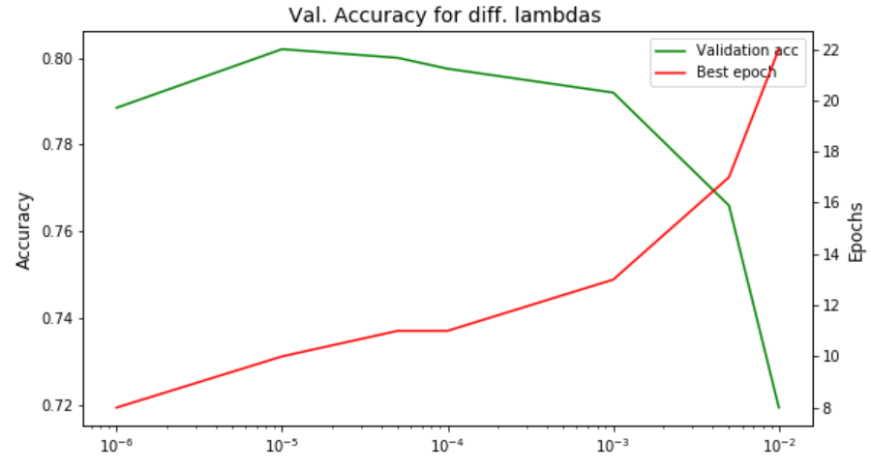

**Effect of L2 regularization on optimal # of epochs**

The red line in the figure above shows the optimal number of epochs for various lambda values. The above figure indicates that for higher lambda values the convergence is slower. i.e. number of iterations for optimal epoch is higher.

**Validation Accuracy vs lambda value**

The green line in the figure above shows the maximum validation accuracy obtained for various lambda values. The above figure indicates that for highest validation accuracy is obtained at lambda = 10-5.

**Optimal lambda value and corresponding validation accuracy:**

Optimal lambda: 10-5, Corresponding validation accuracy: 80.2



**Problem 3 (15 points)**

Consider the network from Problem 1 and examine the effect of dropout regularization by adding dropout layers. What is the optimal validation accuracy when using dropouts?

SOLUTION:

Architecture used : 3.6-Classifying_newswires_a_multiclass_classification_example.ipynb.

Dropout rate used = 0.2

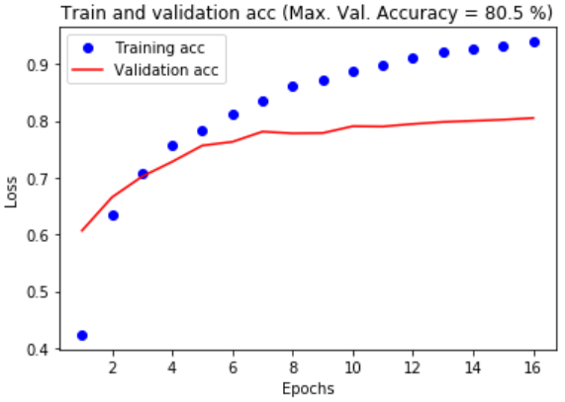

Using the EarlyStopping function is Keras yielded 16 as the optimal # of epochs. Epoch 16 yielded the highest accuracy of 80.5%.



Among Non-Regularized, L2 regularized and dropouts, the architecture with dropouts resulted the maximum accuracy of 80.5.